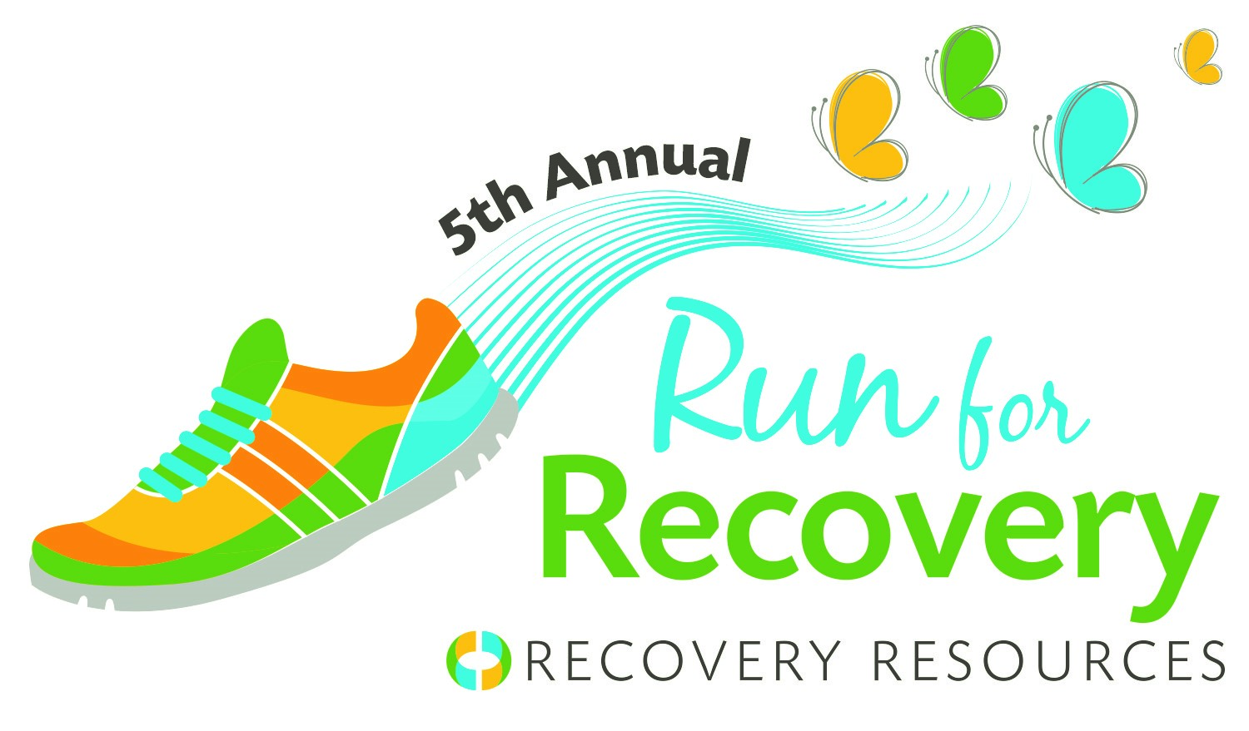
Stories of Loss, Hope & Recovery in CLE
Initiative to highlight toll of addiction on local communities
#RunForRecovery

7/18/2017 (Cleveland, Ohio) – According to the Cuyahoga County Medical Examiner's Office the number of confirmed overdoses in 2016 is 666. The medical examiner expects that number to increase.
To represent, remember, and honor those whose lives were lost, Recovery Resources is launching “Stories of Loss, Hope & Recovery.”

We want to honor those who have lost their life to addiction and recognize those who are in recovery and are learning how to live a life of sobriety.

If you’ve lost we loved one to addiction or know someone in recovery, or you are in recovery and willing to share, please post a photo on Recovery Resources Facebook page and a few lines about them below, or send to acampisi@recres.org.

This summer, we hope to include over 600 participants at the 5th Annual Run for Recovery, taking place August 19th at the Cleveland Metroparks Zoo. We will recognize the 666 lives lost with a special ceremony before the run.

#RunForRecovery
7:00 AM Walk up Registration& Packet Pick up
8:15 AM Opening Cermoney
8:25 AM Kids' Fun Run
8:30 AM 5K-$30
8:45 AM 1.5 Mile Walk-$15
Kid activities

Register or Donate: https://www.wizathon.com/runforrecovery/index.php
Run For Recovery website: http://www.recres.org/RunforRecovery

Leading up to the run, definitions and statistics will be posted on Recovery Resources’ Twitter and Facebook pages. This online resource will help the community discern fact from fiction about drug addiction, including the use of opiates. This social media initiative will launch the week of July 23.

Over the past few years, Recovery Resources has witnessed a rise in the number of people struggling with their addiction and mental illness,” says Pam Gill, President and Chief Executive Officer. “The goal of Stories of Loss, Hope & Recovery in CLE is to help the public make sense of the often-confusing time surrounding drug addiction. This campaign is our part of our commitment to being part of our community’s solution to this crisis.”

INTERVIEWS AVAILABLE UPON REQUEST
Recovery Resources Associate Board Members Zack Yohman and Tera Coleman both watched their mothers suffer from drug addiction and understand the toll addiction takes on families. Their stories can be found on the Recovery Resources YouTube page (www.youtube.com/recres). They are available for interviews upon request.

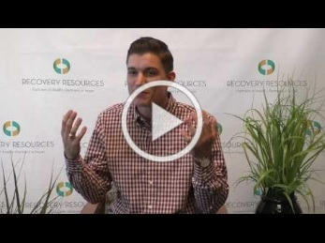

Zack Yohman: https://youtu.be/A7bspXXJyvM
Tera Colman: https://youtu.be/hcsKc_bviIs

ABOUT RECOVERY RESOURCES
Recovery Resources is a trusted partner in the community, providing outpatient programs and services that help adolescents and adults triumph over mental illness, alcoholism, drug and other addictions. The organization is preparing a three-year strategic plan focusing on growth of our core services, while assuring high quality care for our clients. The results of these efforts will ensure Recovery Resources will continue to serve the community as an even better partner helping more people triumph. Founded in1955 and based in Cleveland, Ohio, Recovery Resources can be found online at www.recres.org

ABOUT THE RUN FOR RECOVERY:
Each year, Recovery Resources strives to advance the cause of National Recovery Month. In 2013, we generated community support and awareness by hosting our first annual Run for Recovery. Since then, the Run for Recovery has grown each year, turning into one of the best ways to celebrate recovery.

CONTACT:
Annamarie I. Campisi
Communications & Marketing Associate
216-431-4131, Ext. 2502
acampisi@recres.org

Diane Tomer
Director of Development & Marketing
216-431-4131, Ext. 2501
dtomer@recres.org

